Studio PDR Planning Worksheet

# Personal Details

Name: Jenna Boyes

Date of scheduled PDR meeting: 21st or 24th June 2024 ~~Mid-semester~~/ **Final**

Discussed with:

# Personal Goals and Objectives

This could be for Studio, BIT or general career progression

## Discussion Questions

**1. What are your personal goals and objectives in addition to the course objectives?**  
I want a job to be a game or web dev so I can work from home and work on  
projects that have so much more passion than a networking or hardware-based jobs

**2. What has gone well this semester? What are your strengths?**I am really pleased with how this whole semester has gone. I have really enjoyed the 3D Modelling and World Building papers from the Design School, they have invigorated the creative side of me again. I have also enjoyed Algorithmic Problem Solving as it forced me to view problems from a different perspective, and I am better at coding now due to that. I have learned new skills from Studio 3 too that have given me better teamwork and conflict management skills

**3. What could have gone better and how? What would you do differently next time?**  
If I were to repeat the semester I would have had more of an open mind for Algorithmic Problem Solving. In the first half of semester, I was really struggling with the lecture notes as I felt they were like university notes and hard to understand. Almost every class I was asking my lecturer to help me understand what was happening and I was getting frustrated since I couldn’t do it by myself.

**4. What are the next steps to take? What is your plan for further self-development?**  
I need to keep working hard at Polytech and getting high grades. This is how I will grow my knowledge so I can be better to employ in the future.

**5. What barriers to your success exist? How do you plan to deal with them?**I have a permanent wrist injury and I believe I have ADHD and am on the autism spectrum.  
All these things I am always working on to become a better me, and not allow these differences slow me down too much.

6. What is not clear or is uncertain? In Studio, for BIT, at Polytech etc  
What my life will be like after I graduate. But no-one could tell me cause people cannot see into the future or time travel haha

# Learning Outcome 1: Analyse user requirements to inform technical project work and produce user-centric functionality

## Objectives

* Capture project requirements in the form of User Stories
* Contribute in a meaningful way to coding and releasing features that meet the user requirements
* Demonstrate an iterative approach to project work using Design Thinking techniques
* Participate in code review to ensure high-quality outputs

## Capture project requirements in the form of User Stories

e.g. Links to your best user stories in the project backlog

([link](https://github.com/BIT-Studio-3/group-project-24-1-bug-exterminators/issues/62))  
([link](https://github.com/BIT-Studio-3/group-project-24-1-bug-exterminators/issues/61))  
For this particular sprint Amber was the Scrum Master and started each issue with the description. These 2 issues were my assigned tasks for that Sprint, so I added the User Stories.  
I feel I embodied the players need to fit the technical side of the issue, without pulling technical things into the user story.

## Contribute in a meaningful way to coding and releasing features that meet the user requirements

e.g. Links to Pull Requests showing the contributions you are most proud of

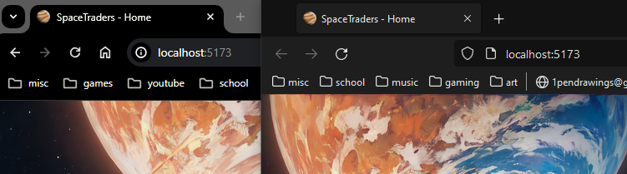  
(the image above shows the product of [this PR](https://github.com/BIT-Studio-3/group-project-24-1-bug-exterminators/pull/45) working in both Chrome and Firefox)

I am most proud of this PR’s features because it is a small change that has a huge effect. I had to research for a long time in many forums and online documentation to find and implement the multiple ways to update <title> using svelte. This PR’s commits show the ups and downs of my work, where I forgot simple svelte code (URL into static/images) but succeeded in the end.

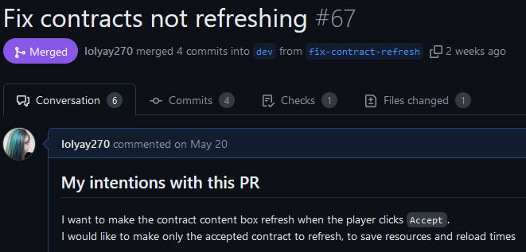([link](https://github.com/BIT-Studio-3/group-project-24-1-bug-exterminators/pull/67))  
The image above shows my last PR, where I fixed a component not working. I am proud of this PR due to me finding an issue that was plaguing the whole team and others could not find the issue. I needed help in the end due to not understanding svelte completely, but I am proud I asked for it.

## Demonstrate an iterative approach to project work using Design Thinking techniques

How have you been iterative this semester? What improvements have you made?

([link](https://github.com/BIT-Studio-3/group-project-24-1-bug-exterminators/pull/67))  
The two images above shows my code being reviewed, and me committing changes in response. In this example I am being iterative by coding the best I can, then asking for a review and that allows me to make it even better.

([link](https://github.com/BIT-Studio-3/group-project-24-1-bug-exterminators/wiki/Sprint-5-Retro))  
The image above shows Sprint 5’s Retrospective, that I added into the wiki for the team.  
I am iterative is this scenario by involving myself in the Sprint Review and Retro every Sprint. This allows the team to iteratively improve together and in code.

## Participate in code review to ensure high-quality outputs

e.g. Links to PRs where you have written constructive criticism in a code review

([link](https://github.com/BIT-Studio-3/group-project-24-1-bug-exterminators/pull/70))  
The above image shows my review on a PR. In this review I use a complement sandwich to make my review feel professional and not targeted at the reviewee. I also add a comment on the specific line that needs attention. This comment includes a code snippet that should fix the issue I highlighted in my review.

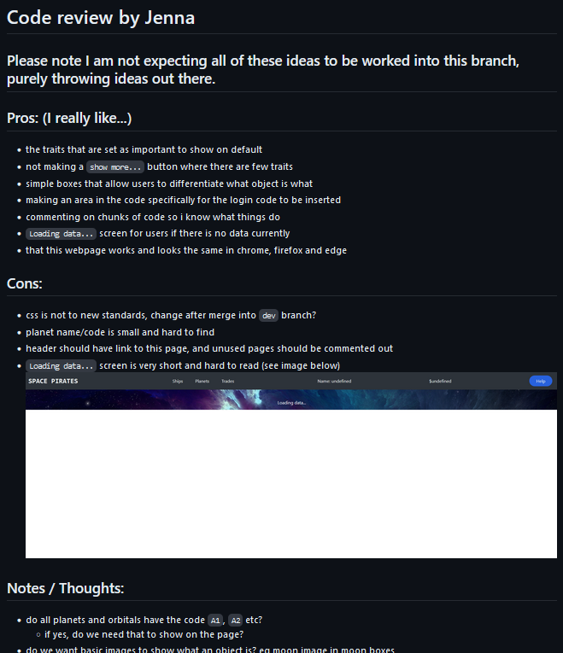  
([link](https://github.com/BIT-Studio-3/group-project-24-1-bug-exterminators/pull/17))

In this code review I commented on good, bad, and other. I tried to keep the complement sandwich form by putting the cons in the middle and notes last. In this review I am professional and positive, and the majority of this review is complements or suggestions.

# Learning Outcome 2: Employ ethical and sustainable development methodologies and tools in a team environment

## Objectives

* Communicate within a team in order to maintain sustainable productivity
* Use industry-standard communication and project management tools in a professional manner
* Contribute to producing safe, accessible, usable and useful software
* Employ leadership and conflict management techniques to sustain an agreed workflow

## Communicate within a team in order to maintain sustainable productivity

Have you been Agile this semester? Have you been a good team member?

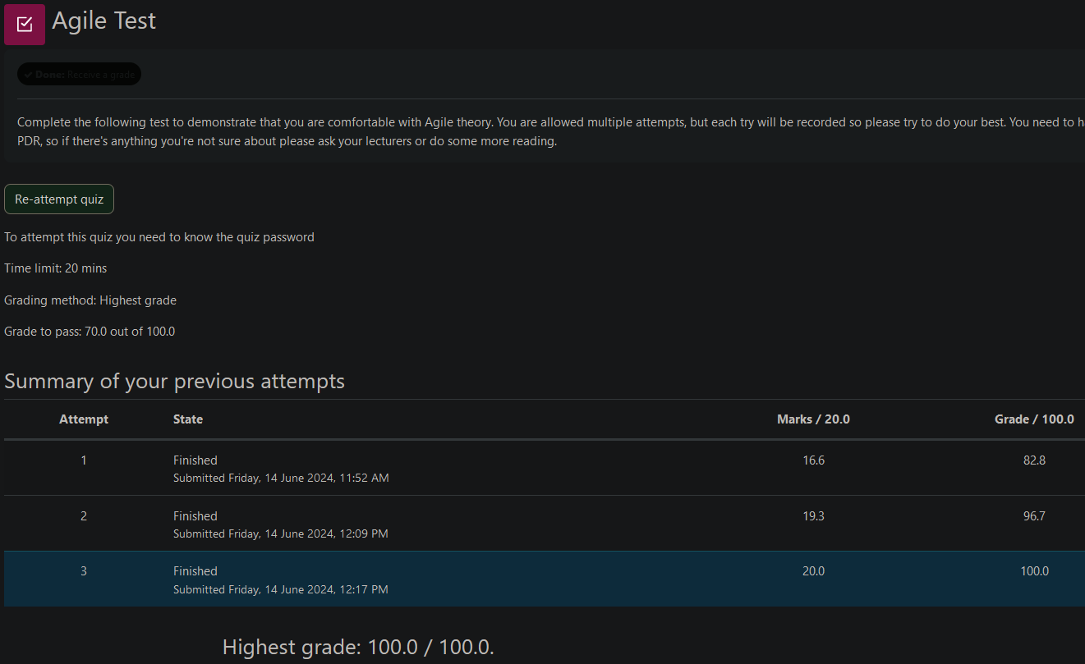  
The image above shows my results in the Agile Test. I can prove that I know what agile is with my grades on this test. My first result was 82.8%, and this was without looking up the scrum guide, and at the end of semester (when I am most likely to have forgotten). I then worked for 100% because I am a completionist. This only proves that I know what Agile is, the following evidence proves I can follow through with my knowledge

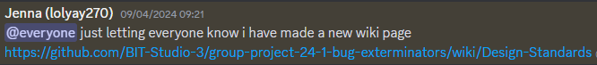  
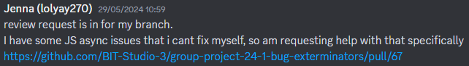  
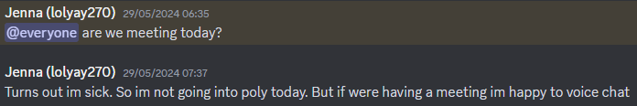  
(all above images are from our private discord group)  
The images above show me communicating with my team. I will mention the person(s) the message is directed towards (using @[person]) so they can find it easier. Most of my communication within the discord group is letting people know of major changes to the GitHub repo because the mobile app is not good at notifications. Otherwise, the messages are about meetings in person, or me explaining my absences to the team.   
These messages in Discord allow the team to be Agile, by quickly communicating, and not expecting GitHub to email someone they have been assigned to something.

## Use industry-standard communication and project management tools in a professional manner

e.g. Have you had a strong presence on GitHub? Have you been proactive in the project?

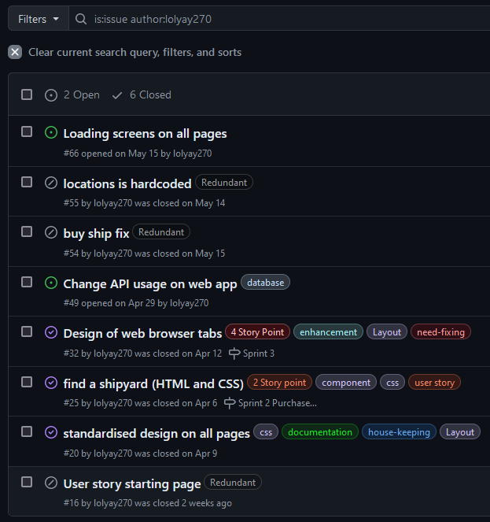([link](https://github.com/BIT-Studio-3/group-project-24-1-bug-exterminators/issues?q=is%3Aissue+author%3Alolyay270))  
This image shows the majority of the issues I make have labels attached. This allows team members to quickly understand what my issue entails. I do the same with my pull requests.

([link](https://github.com/BIT-Studio-3/group-project-24-1-bug-exterminators/issues/32))  
The image above shows one of the issues I made. All of the issues that have an associated PR are linked. The are also assigned to the milestone for the sprint, and added to that Sprint’s kanban board.

([link](https://github.com/orgs/BIT-Studio-3/projects/26/views/6))  
The image above shows segments of the project backlog, including “title”, “Linked pull requests” and “Story Point (Complexity)”. The issues in the product backlog now show the PR they are linked to, and the story point level they have, without clicking and viewing the issue first. I made both of these columns show on the backlog to allow for ease of access for team members.

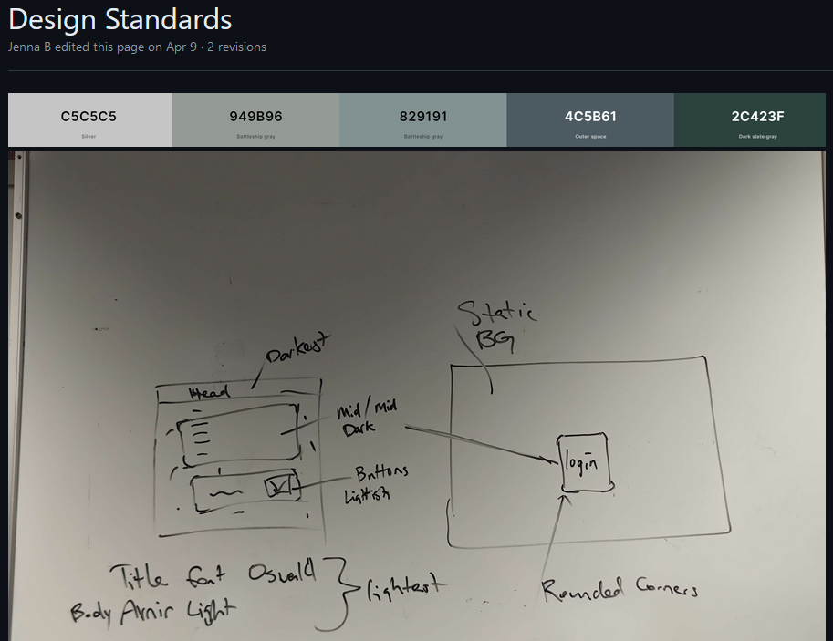  
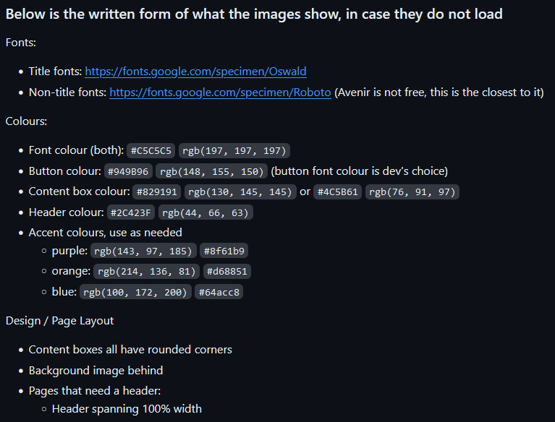 ([link](https://github.com/BIT-Studio-3/group-project-24-1-bug-exterminators/wiki/Design-Standards))  
I was the one who pushed the team to make a standardised design, and then added that to the repo’s wiki. I also wrote out the information in the images with Markdown. This is because in previous projects the images were not permanent and the links expired.

## Contribute to producing safe, accessible, usable and useful software

e.g. Show evidence that you have made accessibility/privacy/security improvements or suggestions

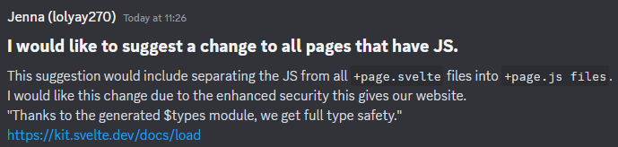  
This image shows a suggestion I gave to the team in our Discord. The suggestion involves improving the security of the website so users cannot access private information.

In the above image I reviewed a team members code. I ensured that the product they were delivering was usable for the players.

    
(browser tabs from before (left) and after (right) I fixed them)  
I made an [issue](https://github.com/BIT-Studio-3/group-project-24-1-bug-exterminators/issues/32) to fix the text and image in the browser tabs because they were not useful and were confusing Svelte or Vercel information. This means users could not tell what our browser tab was without clicking on it and manually checking.

## Employ leadership and conflict management techniques to sustain an agreed workflow

e.g. Did you adhere to the group’s agreed processes? Did you encourage using Scrum properly?

(the above images are from our private discord group)  
The two images above show me guiding the team to use GitHub correctly. The first image is about making PRs that are directed to our staging branch “dev”, not main. This was confusing a few team members. The second image shows me guiding the team to write their intentions as the pull request description so someone could continue their work if needed.

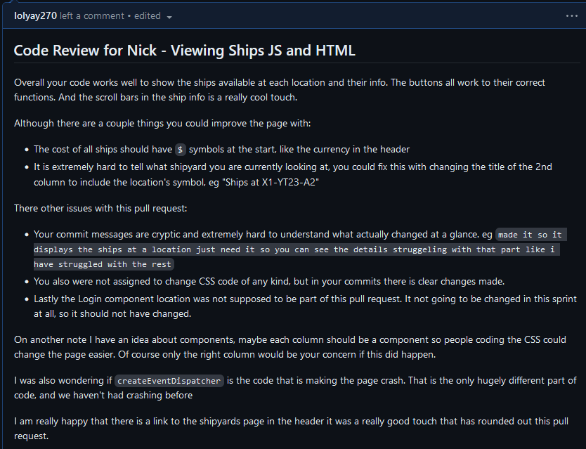([link](https://github.com/BIT-Studio-3/group-project-24-1-bug-exterminators/pull/34))  
The above image shows a pull request I made that I am not proud of. I was rude and used non-professional language to explain my thoughts. After this review was made I was not in a good space with Amber, but we talked it out and both apologised for our wrong doings. We are even better friends now than we were before this instance. This review is always in my mind when I complete new reviews, so I don’t make the same mistake. I am not proud of what I did then, but I am glad I have learned and bettered myself from the situation.